**PowerSDR 2.7.2 ke9ns Feature add list:**

**VFOA/B and Meter Color:** Select accent color under setup->Appearance-General->Ring. When you MOX the radio, the VFOA or B ring will turn RED (depending on which is the TX.  
 **BANDSTACK:** To Open: Left Click on the BandStack Index# (located just below the Tune Step [top center] of the console window) and a BandStack screen will display all memories in the BandStack for the current band, and highlight the current Index.  
LEFT CLICK on a Bandstack memory to go to that memory Frequency.  
ADD entry to the list: Hit the CTRL button and RIGHT Click on the Band button.  
LOCK an entry: RIGHT CLICK on a Bandstack memory to LOCK (freeze) or UNLOCK a memory.  
SORT all entries: Click on the Sort button.  
DELETE entry: Click Mouse WHEEL over entry you wish to delete.  
  
To UPDATE a memory, the current Bandstack memory must be unlocked. Select new Frequency, then either Left Click on a different memory in the Bandstack, OR click on the same BAND button again to go to the next Bandstack in memory.  
NOTE: Frequency, Mode, and Filter are saved/updated only if the memory is unlocked

**TUN button:** Right Click to toggle TUNE button between **TUN** = Standard continuous wave TONE, and **TUNs** = **Pulser TUNE mode**. Go to Setup->Transmit and select pulses/second and duty cycle of pulser.

**DRIVE Level Lock:** Right Click on DRIVE: text (just above the drive power level slider) to **LOCK = RED** or **UNLOCK = WHITE** Drive level (as well as the TUNE drive level). Be sure to preset the drive levels for each band before locking. It will not prevent the levels from changing when you change bands. **MUT button:** Right Click on MUTE button to toggle between Muting all sources or Muting just the speaker (not the headphones, and not VAC1). “MUT” = standard mute, “MUTs” = mute speaker only.  
 **VOACAP (Voice of America Coverage Analysis Program) algorithm to PowerSDR tracking map:**Using Date, Time, SunSpot#, Frequency, and selecting your Lat & Long location using a Dipole , a dBw propagation map (expressed in S units) is created and presented onto the “Track”ing World Map. Dots represent the Signal strength of a person at that location (around the Dot) trying to Receive your Transmission. The map is calculated to be reciprocal, so if they can hear you, you should hear them.   
Select either Signal strength Dots or Contour lines:  
Small Gray Dot=S1-S2 (will only appear in CW mode). Small Orange Dot=S3-S4, Med Yellow Dot=S5-S6, Large Green Dot = S7-S8, Large Blue Dot = S9-S9+. +. And, the Signal strength shown on the map needs to exceed your background Signal noise level. So if you see an S4 over an area of the map, but you have an S7 noise level, you may not hear them.  
The SunSpot# will only work when you activate the PowerSDR console Space Weather (lower Left side of screen). You can select between Dipole and 3 element yagi Beam and select your power output from 1 to 1500 watts.

**Griffin PowerMate USB Knob:** You can now have a separate tune step rate for the PowerMate knob as opposed to the Mouse wheel. Setup->General->User Interface->Independent.

**Read the BCD Time coded sub-carrier from Radio Station WWV:** Select a frequency (1=2.5mhz Night, 2=5.0mhz Evening , 3=10mhz Late Day, 4=15mhz mid Day). Check the “Use WWV HF” check box (in Spotter window) to Decode Radio WWV Time/date. The passband will be reduced to 160 to 160 hz, around the 100hz sub-carrier. Now you will only HEAR the 100hz TICK sound (you will NOT hear the normal Tone signals or voice announcements. The “Tick” indicator should go ON/OFF in sync with the 100hz Tick your hearing. If a deep fade occurs during the Decoding process (P1 to P4), the decoder will STOP and tell you to try again on another frequency with a stronger signal.  
PowerSDR must be in ADMIN mode to allow to sync your PC.   
 **“TIME SYNC”: NIST (National Institute of Standards and Technology) PC Time Sync:** If you run PowerSDR in ADMIN mode, you can use the “Time Sync” button (in the Spotter window) to sync your PC time clock to NIST. (don’t check the WWV box if you want to use the internet to update your clock) **NCDXF Beacon Scanner:   
This feature gives you a direct method of determining radio wave propagation conditions(i.e. band conditions) for the 20m,17m, 15m,12m, and 10m bands. A System of 18 stations, around the world, transmitting (24hrs / day) in 10 second intervals on 5 frequencies (5 separate stations simultaneously) on 14.1mhz, 18.11mhz, 21.15mhz, 24.93mhz, and 28.2mhz. (Repeating every 3 minutes).Your PC clock must be accurately set to make sure PowerSDR matches up with the Beacon stations.**Under the “Spotter” window is a “Beacon Chk” button with Fast & Slow Scan options. You will see a list of Beacon stations (upper left corner) and the current 5 stations transmitting). With “Map Calls” checked, you will see all 18 stations (and each of their 5 frequencies).   
  
Slow Scan: Starts on 14.1mhz beacon and listens for 3minutes (1 complete loop) for 18 stations and records their signal strength, then moves to 18.11mhz, and so on, until 28.2mhz. 15 minutes total time. You can select the starting band 1 through 5. 1=14.1mhz up to 5=28.2mhz.  
Fast Scan: Scans through all 5 Beacon frequencies (1 second per beacon) in a single 10 second interval, and records the signal strength on each frequency. It repeats this quick 5 frequency scan 18 times to get a complete Beacon map in 3 minutes, but is not as accurate as the Slow Scan.  
  
Colors On the World Map: Gray = Not scanned yet. Violet = Currently Scanning, Red = Not detected, Orange = Weak, Yellow =Light, Green =Strong.  
On the SPOTTER window: All 18 stations x 5 frequencies are listed (total of 90 entries)  
As the stations and frequencies are scanned, signal data is added to the SPOTTER entries.  
-NA dBm = Not Scanned yet. S9 -018dBm = S9 signal level, but only -18 dBm above the noise level.

At the Start of any Scan, the Mode is changed to CWU with filters set to 550hz - 650hz. This is to try and eliminate extraneous noise. Prior operating Mode and Filter High/Low settings are restored when the scan is finished.  
see <http://www.ncdxf.org/beacon/index.html> for further details  
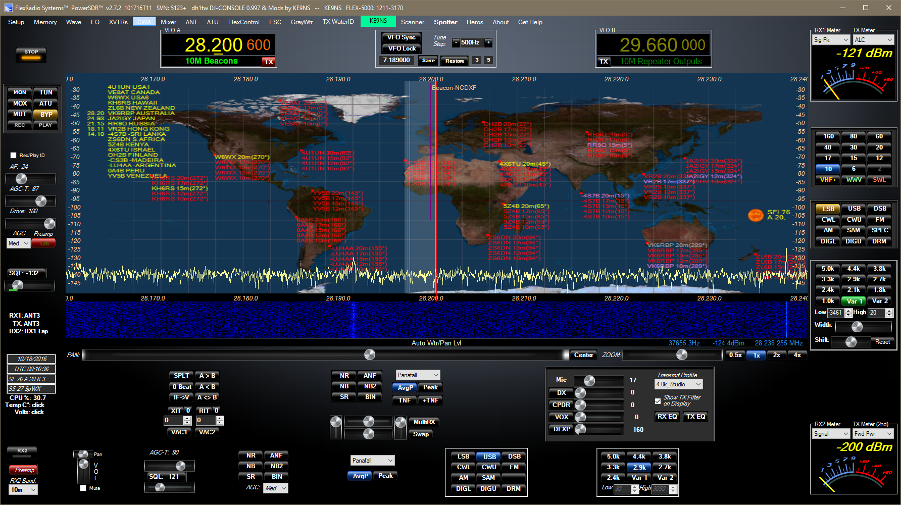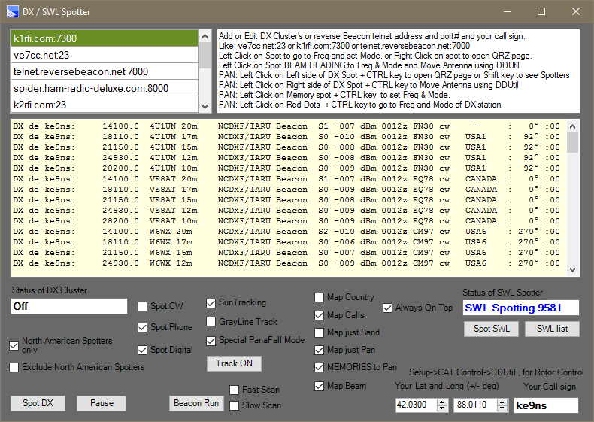

**Automatic Antenna Control:** Setup->CAT Control->Enable Rotor. You must select 1 side of a virtual COM port pair. The other side of the COM pair connects to DDUtil. DDUtil will automatically convert the beam heading into the proper format for your Rotor control.  
Left Click on the BEAM HEADING of a DX spot in the Spotter window to Move Antenna  
OR, Left Click on the Right Side of a DX Spot + CTRL Key in the Panadapter to Move Antenna   
In DDUtil open setup form->AntRtr and setup your antenna Rotor control(s).  
 Then go to setup form->Ports->RCP1->Rotor Port and the “Other side” of the COM pair from PowerSDR.

**MP3 output:** Scheduler/Recorder automatically saves only in MP3. Wave->QuickAudio Create MP3 checkbox, saves a WAV file and an MP3 file (For emailing the audio files to friends)

**VFOA Slider:** Left Click on PAN: text to free up the VFOA to slider around the display.  
 **SWL BANDS:** 14 standard Shortwave Listening bands, each with their own Bandstacking memories. **SWL SPOTTER:** SWL.CSV database file (from eibispace.de) provides over 11000 shortwave broadcast, utility, and government frequencies all displayed directly on the Panadapter. CTRL+ Click on a station to open up a google search.  
**SWL Listing screen:** Displays currently operating SWL stations by Frequency and is SEARCHABLE by Station Name. Left Click to go to frequency. Attempts to determine the mode (AM, DIGU, USB, CW).   
**SWL Additional list**: SWL2.csv provided by ke9ns adds SWL and HF Utility frequencies not found in the eibispace.de SWL.csv file. PowerSDR stiches SWL.csv and SWL2.csv together when you run the SWL spotter.  
 **DX Beam Heading:** Enter in your Lat and Long next to your Call sign in the Spotter window, and see Beam heading from your Station. Map Checkbox to see beam headings on the Tracking Map.  
**DX CLUSTER**: Using and internet and a DX Cluster URL address:port, and your callsign, DX station data shows up in a window based on time, checking for duplicates in frequency and call sign. Left click in this list to go directly to Frequency parsing out operating mode, and split. Right click to go to QRZ page   
**DX SPOTTER**: Displayed directly onto the Panadapter. CTRL + Click on spot in Pan, goes to QRZ page. SHIFT+Click on spot in Pan, alternates display from Spotted to <Spotter>. 6m includes grid data  
**Grayline & Suntracker**: World map plots Sun and/or Grayline, including Solstice and Space Weather data. Grayline has fill color and transparency settings and can be turned off separately.  
**Special Panafall mode:** 80% map, 20% waterfall.  
**Mapping DX spots** directly onto map which are live and selectable: CTRL+Click over red dot, to go directly to frequency, mode, and split.   
**MEMORY list mapped** directly to Panadapter. CTRL+Click on memory in Pan, to adjust filters, mode  
**MEMORY Added** directly from Display: ALT+M key  
**MEMORY Hyperlinking**: Drag/Drop a URL or file directly onto highlighted MEMORY (from memory screen). Right click on highlighted memory (from memory screen) to activate stored Hyperlink.  
**Memory (Scheduling & Recording):**You can now save a start Date & Time to change Frequency and optionally Record, repeating based on either the Week, or the Week of the Month. (i.e. Every Monday, or Last Monday of every month)  
 **Bandstack Memory Window**: Bandstack index# and size on main console window. Right click to open window. Add up to 9 memories (every band) with CTRL+Right Click on Band button.  
**Bandstack LOCK/UNLOCK** feature for each memory in each Bandstack. Right Click on bandstack memory.  
  
**NOAA space weather** on main console screen (SFI, A, K, SSN) in addition to PA Temp and Voltage.  
**Panadapter Fill color and Transparency**.  
 **New Analog Meters**: Click on meters to cycle through all 3 (can also change colors). Also added RX “Signal peak” RX mode  
**2nd TX Meter Function**: allows you to view 2 TX meter functions at the same time. Appears where the RX2 meter would be.  
  
**One Touch Automatic Small signal Panadapter Scale adjustment button:** Left click on “Zoom:” text **One Touch Automatic Waterfall Adjustment button:** (RX & TX) with offset adjustment sliders.  
**One Touch Automatic Panadapter Adjustment button:** (RX & TX) with offset adjustment sliders.  
**Separate waterfall Low levels for TX display** and RX2.  
**RX1 and RX2 both display in PanaFall mode at same time**.  
**Waterfall History moves** with Panadapter, so the history is always accurate.   
**Gray waterfall** (for viewing waterfall text and images)  
**TX WaterID:** Transmit your call sign directly into the waterfall so anyone with a DSP can see your call sign (or transmit an bmp image)  
 **RX1 mute** allow VAC to continue, while still listening to RX2  
**CWX panel** polls CW Key to interrupt message queue. Speed of CWX and CW key panel synced.  
**Direct Frequency entry in KHZ** or MHZ (both VFOA and VFOB)  
Native **Griffin PowerMate** USB knob support: no extra software  
Native **DJConsole** USB support: no extra software  
  
**Quick Audio Save folder** allows multiple saved recordings that can be played from the main console screen REC and PLAY buttons  
**PLAY button**: Right click to see folder with your quickaudio files you can select from  
**Rec/Play ID feature**: <REC>: Auto Record your voice. <PLAY>: Auto Play to Transmitter. For Contesting.   
**Monitor function for AM/FM** modes (with limitations)  
**Monitor Pre and Post** options (MONpr and MONps)  
**DSP Options (i.e. NR, ANF, NB)** reset to default buttons added.  
**TNF** adjustable width  
**Band Scanner** function  
**Continuum** display mode for RX1  
**Corrected S9 reading above 30mhz**  
**10khz wide TX** Audio for 1500 and 3000  
Opened up **RX Audio to 15khz/side** (30khz total)  
**Right Click** on many buttons to go directly to setup screens (i.e. VAC1, NB, transmit profile)  
Fix 6m lower limit for UK  
Fix Full duplex (with RX2) operation not allowing VAC1 when transmitting on VFOB